
Community Heritage Grants

Application Assessment Framework

Purpose
This framework ensures consistent, fair, and transparent assessment of all grant applications submitted to the Community Heritage Grants Scheme. It will be used by DHET staff and the grants committee when reviewing applications.

Assessment Criteria & Scoring
Each application will be assessed against the following criteria. All are scored on a scale of 0–5. Assessors should write the score for each criterion in the box provided. Use the scoring guide below when allocating scores. Maximum score -30

Scoring Guide
0 = Not addressed (criterion not covered in application)
1 = Very weak (minimal evidence, major concerns)
2 = Weak (some evidence, significant gaps)
3 = Adequate (meets minimum requirements)
4 = Strong (well-developed, few concerns)
5 = Excellent (outstanding, fully meets/exceeds expectations)

Decision Thresholds
24–30 = Strong priority for funding (subject to budget availability)
18–23 = May be funded (if budget allows; may require conditions/revisions)
Below 18 = Not recommended for funding

CH008 Strands of Connection
The Strands of Connection" is an immersive heritage and well-being programme that explores the historical and cultural "warp and weft" between Dundee’s textile industry and the global heritage of Yoga. Centred on the translation of the Yoga Sutras (literally "Yoga Threads/Strands"), the project brings oral histories, classical scholarship, and adaptive sound/movement into Dundee’s historic spaces to empower the elderly, disabled, and youth.
The grant is requested for staff heritage training/oral history training and a one day pilot event consisting of four workshops/ yoga sessions and Gaelic Heritage sound bath experiences within the Verdant workspace to allow people to experience the space under a different purpose. The Heritage Lottery have shown interest in this as a test case for longer term project funding and the success of the event will be measured and presented to Heritage Lottery after the event. The sessions will begin with talks on the cultural significance of the building in Dundee's history, and the use of the space now.
Heartspace will welcome people from the community into the space to engage with it in a different way while gathering video and photographic content about accessibility, personal connection to heritage, and people's connection to heritage spaces.
Originally Heartspace had asked DHET for full payment of £1,500 for hire of the space for the day but on the recommendation of DHET they worked to broker a partnership with Verdant works to get the space free. This partnership is now leading to more heritage opportunities for Heartspace going forward.
Grant eligible costs: £4,220
Grant requested: £2,500

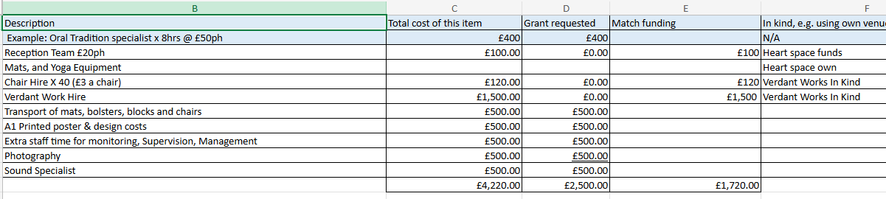

Application Assessment

Criterion | Description | Score (0–5)
Strategic Fit | Project aligns with HES priorities:  • Increase understanding of and engagement with Scotland's historic environment  • Enhance communities’ use of the historic environment in place making  • Strengthen the resilience of Scotland's historic environment  • Use the historic environment as a catalyst for climate action  • Increase the quality and availability of historic environment skills  • Increase economic benefits from the historic environment in sustainable and inclusive way | 5/5  Strands of Connection is a strong thematic match for the grant’s priorities because it connects Dundee’s textile heritage with the global heritage of yoga and places that interpretation inside Verdant Works, a historic environment setting. The project clearly supports increased understanding of and engagement with Scotland’s historic environment, while also encouraging communities to use heritage space in an active and meaningful way.
Community Benefit | Clear evidence of local need and benefit to Dundee communities (reach, inclusivity, impact). | 4/5  The application sets out a clear focus on older people, disabled participants, and young people, with an inclusive and welcoming approach. It also proposes to collect feedback, testimonials, photographs, and attendance data, which should provide evidence of community reach and impact. The case for local benefit is persuasive, although the Dundee-specific evidence of need could be stronger.
Project Design & Feasibility | Clear aims, realistic plan, achievable timeline, and necessary permissions in place. | 3/5  The project idea is coherent, and the planned activities are well described, including oral history training, yoga sessions, chair yoga, Gaelic and Heritage sound bath experiences, historical talks, and participant feedback gathering. Some operational detail around practical delivery arrangements still needs to be clarified with Community Engagement Advisor
Value for Money | Budget is reasonable; costs are balanced; includes match funding or in-kind support. | 5/5  The budget is modest and broadly proportionate to the activity proposed, with eligible costs of £4,470 and a grant request of £2,500. The application also shows in-kind and match contributions, which strengthens the value-for-money case. Overall, the budget appears reasonable for a pilot project of this type.
Organisational Capacity | Applicant demonstrates ability, experience, and resources to deliver the project. | 5/5  Heart Space Dundee presents as an established organisation with a clear community remit, accessible practice, and trauma-informed delivery experience. The application suggests that the team has the skills and credibility needed to deliver the project, including the ability to work with community participants and partners such as Verdant Works and Our Story Scotland.
Legacy & Sustainability | Potential for lasting impact beyond the project (skills, partnerships, awareness). | 4/5  The project has good legacy potential through testimonials, photos, and increased awareness of heritage spaces, and a strong post-project continuation plan through partnership with Verdant Works and Our Story Scotland. This can be explored further on completion of the pilot event.
Total Score: 26
Recommendation:
This application is recommended for funding at 60% of total Project Cost = £2,500

